CIA 4003 - Advanced Mobile Applications

Coursework Assessment

202310



|  |  |
| --- | --- |
| **Student name** | **Student ID** |
| Fatma Ramadan | H00445683 |
| Maryam Waleed | H00445586 |
| Mariam Abdelmalik | H00445836 |

Table of Contents

Introdution 3

pages 3

main pages: 3

sign UP page: 4

logIN page 5

About the Association page: 6

Property type and size: 7

Book a cleaner page: 8

Payment page: 9

Thank you page : 10

Feedback page: 12

## Introdution

Welcome to the Student Association! Our vision is to create a vibrant and inclusive learning community where every student, regardless of their background, enjoys access to high-quality EMSAT, SAT, and IELTS preparation resources. We believe that you've got potential, and that hard effort and devotion are necessary to succeed on the EMSAT, SAT, and IELTS exams. Passing these tests isn't the only goal; passing them can lead to interesting possibilities and a brighter future. With the correct direction and your determination, amazing outcomes are possible. We're here to support you every step of the way. Our mission is to assist students in preparing for EMSAT, IELTS, and SAT exams, empowering them to achieve academic and professional goals. We foster a collaborative learning environment where students can share knowledge and experiences. Our goals include creating a supportive community and providing the tools and guidance for excellence in EMSAT, SAT, and IELTS exams. Join us on this journey of learning and growth!

## FIREBASE

* The fire base Shows the collection of data is stored.

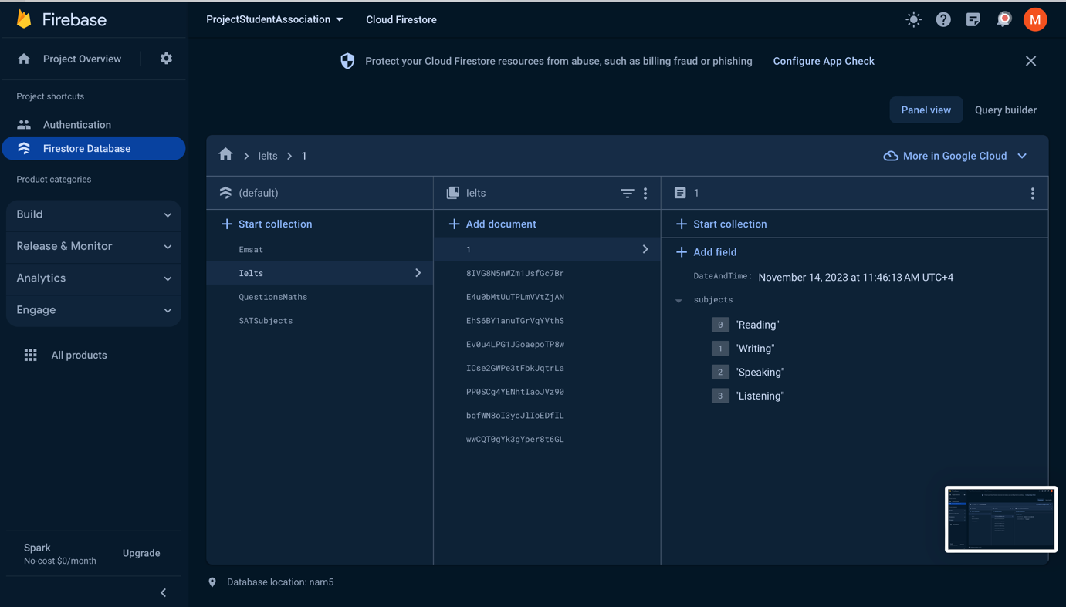

* The stored user data .

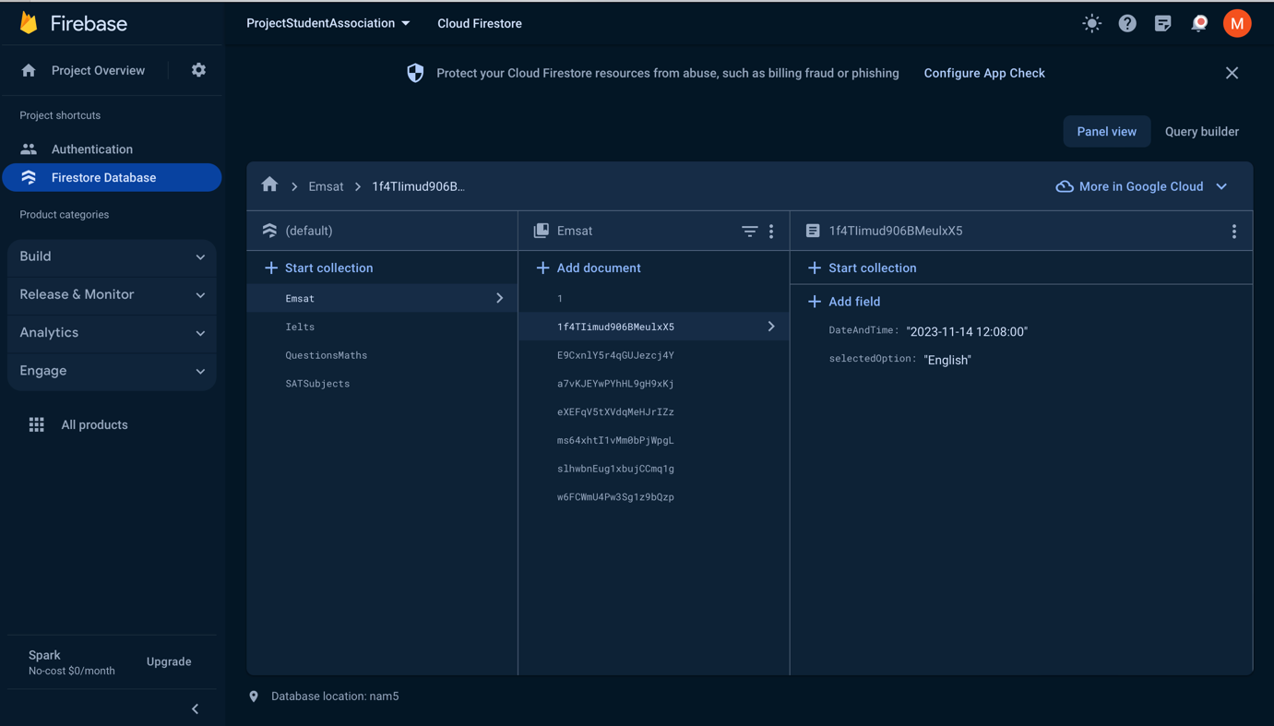

* The stored data for the question page.

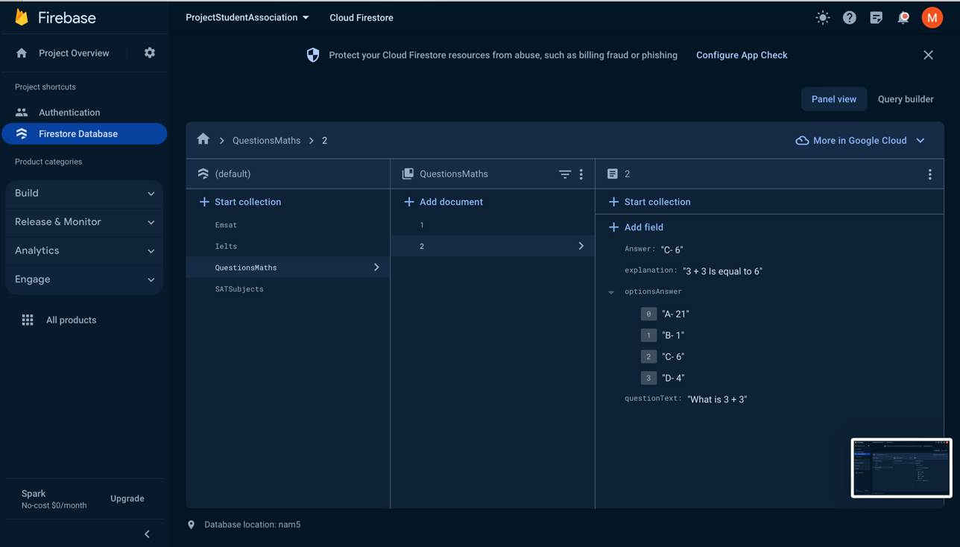

## pages

### main pages:

- Our main page provides users with a comprehensive overview of our application's functionality, accompanied by supportive and informative content.

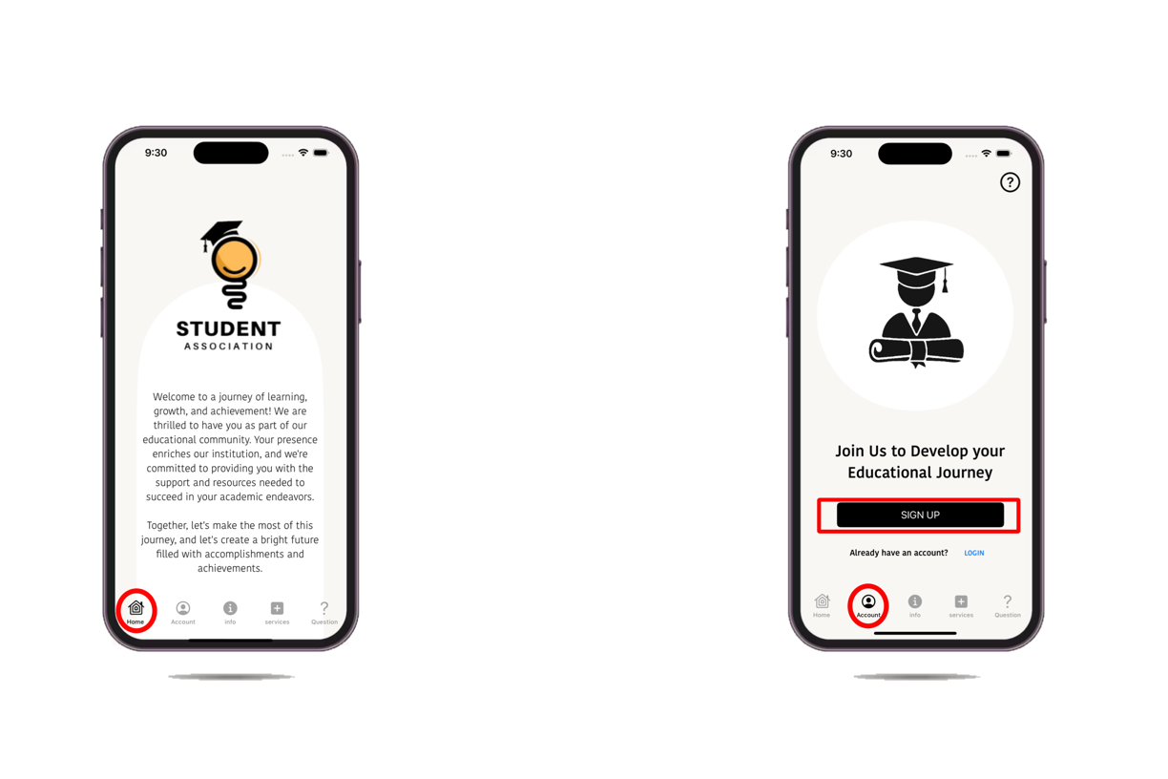

### SIGN UP AND logIN PAGE:

-When a user visits a sign-up page, they will typically see a form or input fields where they can enter their information to create a new account.

- Requires user identification and authentication, regularly performed by entering a username and password combination; the account will be saved in Firebase.

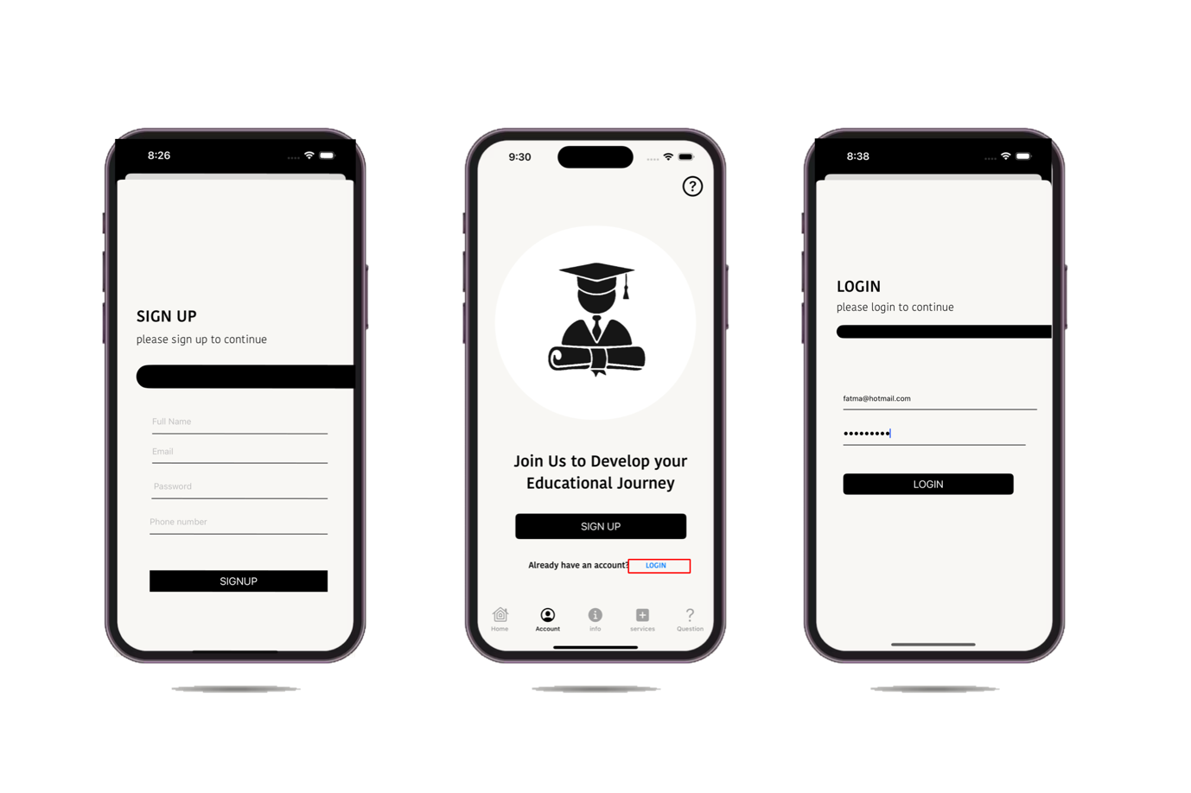

### About the Association page:

-This page succinctly outlines the key information about student assistance, encompassing our vision, message, and objectives.

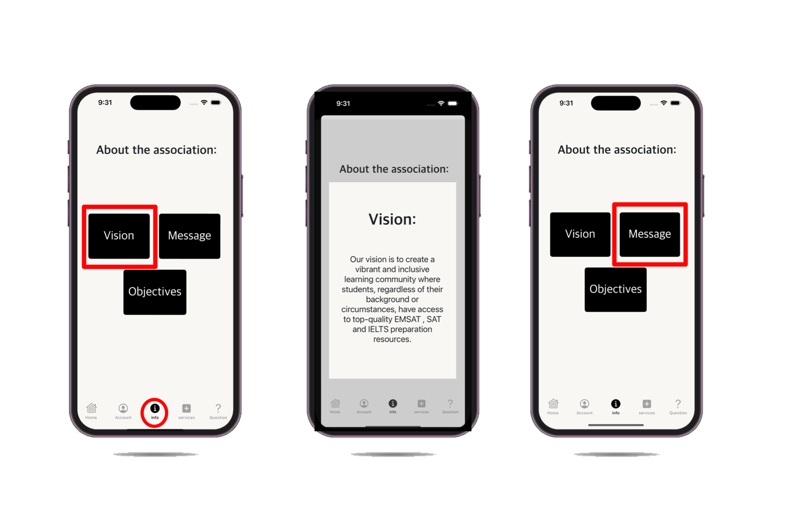

### Book aN exam REVIEW pageS FOR ILETS, EMSAT AND SAT:

* Users must log in to access the displayed service pages. Upon logging in, the service page will be presented, offering users the option to choose from three services, book a study session, and share documented.

* Once the user selects a specific service, they can seamlessly schedule a study session by specifying the day, time, and subject. Additionally, users will have the capability to view the history of past sessions for reference.

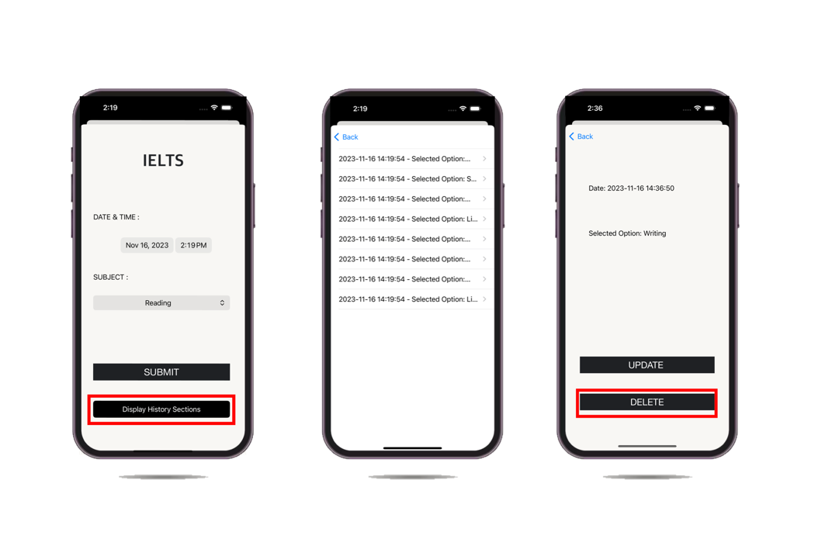

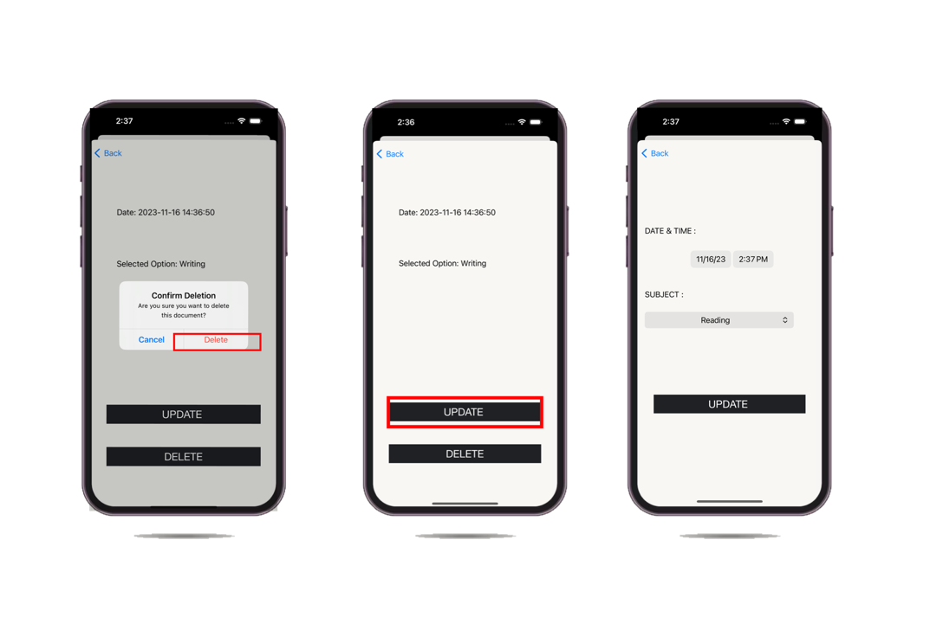

### REVIEW QUESTIONS FOR ILETS, EMSAT AND SAT pageS:

* The tab bar located at the bottom of the screen features the "Questions" page and other services. This question page is designed to assist users in reviewing various questions and is accessible to all users, not just those who are logged in.

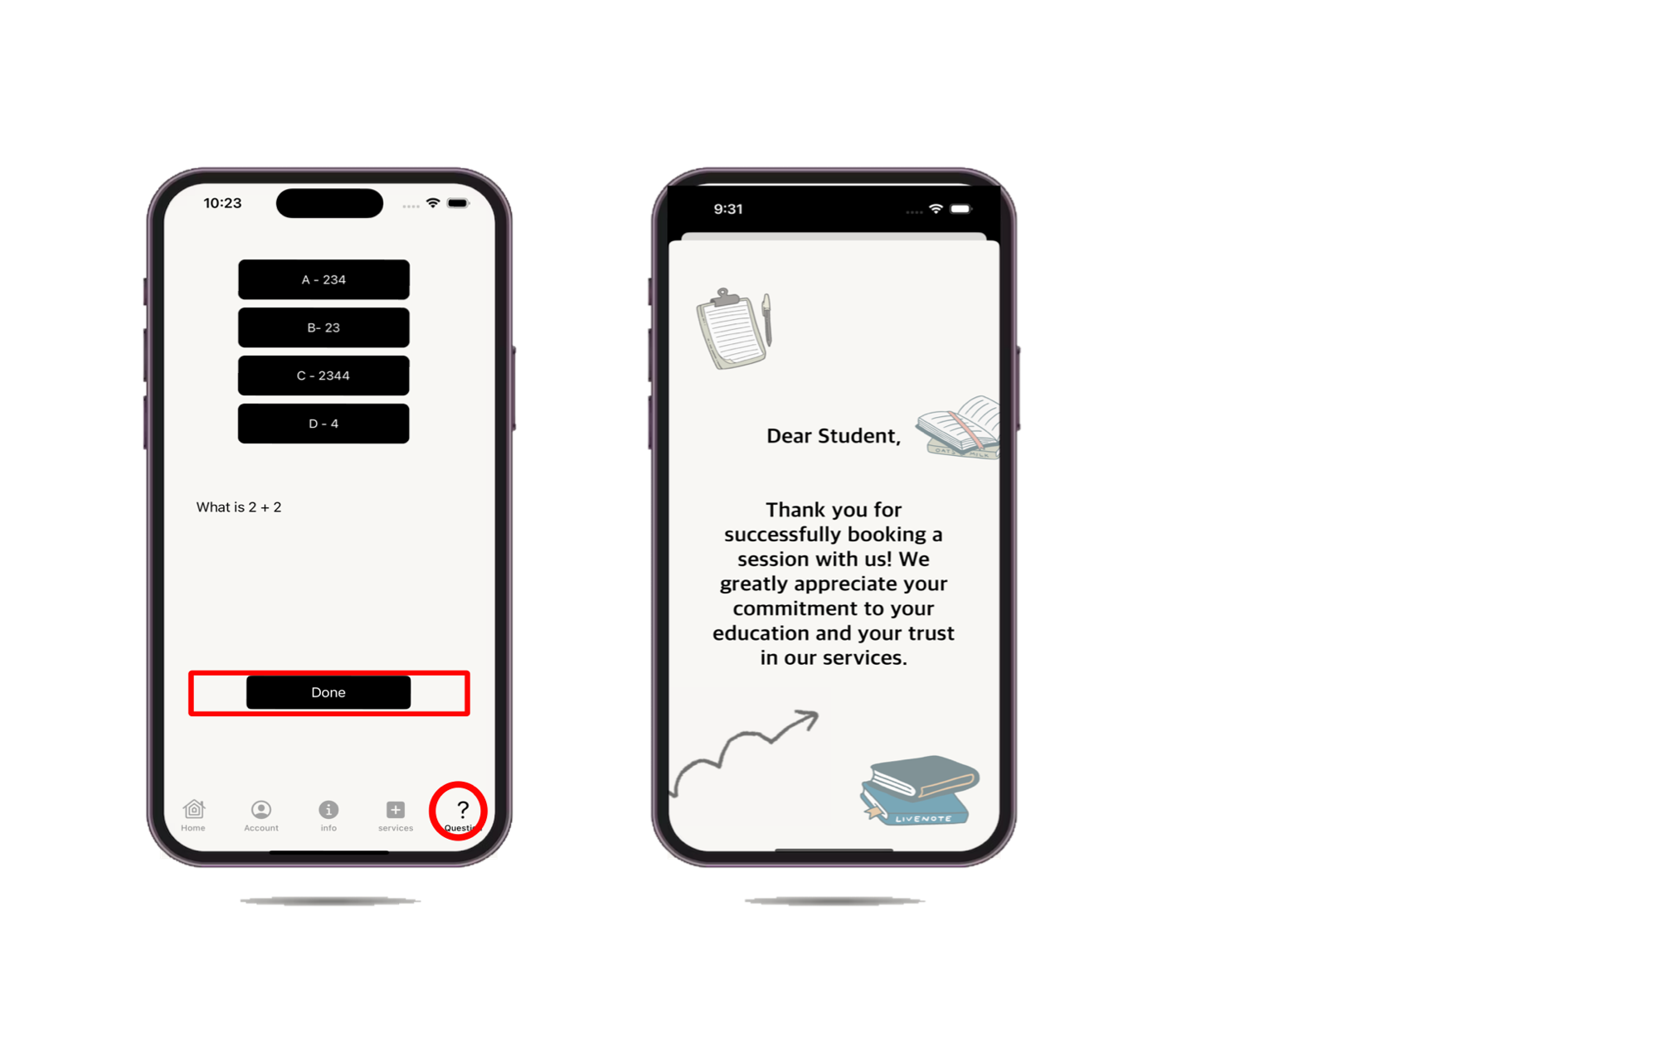

### Thank you PAGE:

- Upon submission of the booking session, a Thank You page will elegantly appear, conveying a supportive message to the user.

